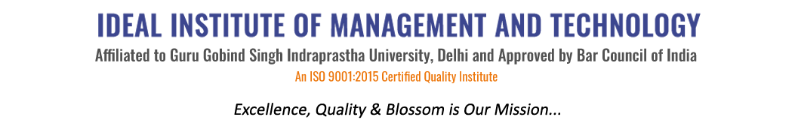
16 X, Karkardooma Institutional Area, (Near Telephone Exchange)
Delhi-110092
+91 (11) 22372639, 22375961,
http://idealinstitute.edu.in
INDUSTRIAL VISIT MOTHER DAIRY - 17TH NOVEMBER' 2015
BBA 2ND SHIFT
S.no. | Name | Class | Amount | Attendance | Attendance
1 | Prachi | CAM-4 | 150
2 | Farheen | CAM-4 | 150
3 | Jai | CAM-4 | 150
4 | Harshit | CAM-4 | 150
5 | Gunjan | CAM-4 | 150
6 | Pragya | CAM-4 | 150
7 | Utkarsh | CAM-4 | 150
8 | Ashutosh | CAM-4 | 150
9 | Saba | CAM-4 | 150
10 | Vikram | CAM-2 | 150
11 | Anubhav | CAM-2 | 150
12 | Abhishek | CAM-2 | 150
13 | Deepanshu | CAM-2 | 150
14 | Ruchika | CAM-2 | 150
15 | Vishv | CAM-2 | 150
16 | Piyush | CAM-4 | 150
17 | Jhanvi | CAM-4 | 150
18 | Riya | CAM-4 | 150
19 | Divyansh | CAM-2 | 150
20 | Gaurav | CAM-2 | 150
21 | Saumya | CAM-2 | 150
22 | Aman | GEN-4 | 150
23 | Sukhleen | GEN-4 | 150
24 | Pranjal | GEN-4 | 150
25 | Vaibhav | GEN-2 | 150
26 | Apurva | GEN-2 | 150
27 | Samiksha | GEN-2 | 150
28 | Shalu | GEN-2 | 150
29 | Parul | GEN-2 | 150
30 | Lipi | GEN-2 | 150
31 | Chetan | GEN-2 | 150
32 | Cheshtha | GEN-2 | 150
33 | Arpit | GEN-2 | 150
34 | Garima | GEN-2 | 150
35 | Ayushi | GEN-2 | 150
36 | Apoorv | GEN-2 | 150
37 | Archit | GEN-2 | 150
38 | Abhishek | GEN-2 | 150
39 | Saksham | GEN-2 | 150
40 | Anant | CAM-2 | 150

